A4053-ME-Persia-Jiroft-Vases-Chlorite-2750 BCE

Jiroft-Civilization 027.jpg  
The Jiroft culture is a postulated Early 3rd millennium BC archaeological culture located in what is now Iran's Sistan and Kerman Provinces. Jiroft, a small city in the southeastern province of Iran, Kerman, has become a center of archaeological interest after the 2001 flash flood revealed one of the “forgotten and lost” civilizations of the ancient world. The more utilitarian versions of these truncated pyramidal vessels were probably used for transporting prized unguents and perfumes, probably some originating in the Arab world such as frankincense and myrrh. The current vessel with its crosshatching was probably one of these vessels.  
www.omidvar.net

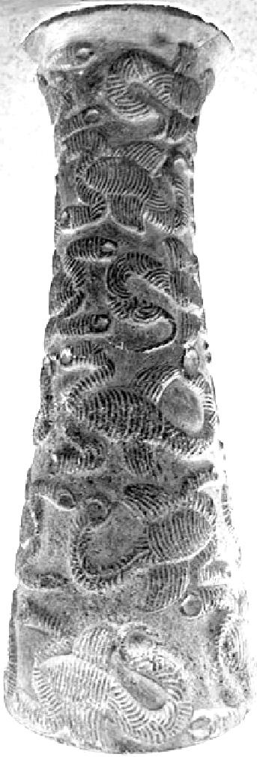 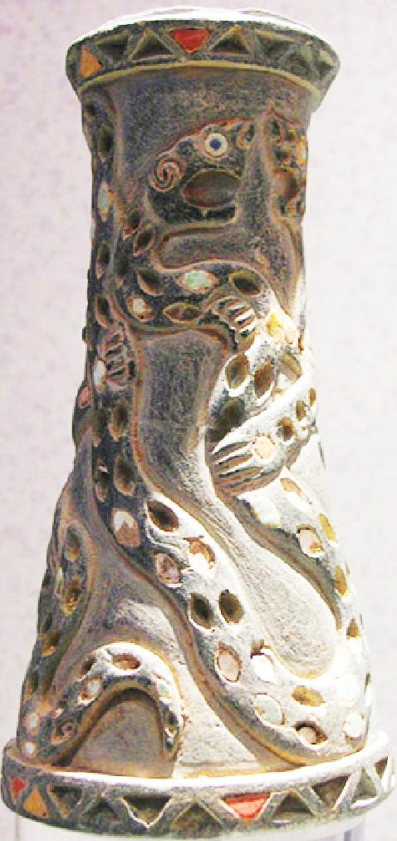 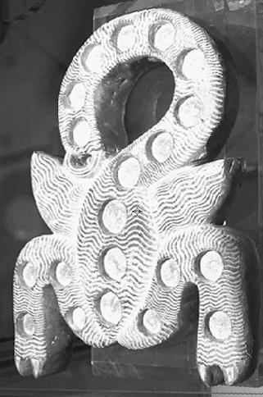v

